More than youth ministry; we are FAMILY!  Youth gather for a great time of faith based fellowship on Tuesday and attend Wednesday/ Sunday services.  Tuesday nights consist of youth activities and fellowship which welcome an atmosphere of open, topic-based discussion as well as hands on learning.  Wednesdays & Sundays offer a variety of services which include youth focused lessons along with a powerful Praise & Worship service.  Periodically, out of town trips take place which include educational experiences and promote Christian fellowship.  FOLLOW US:  Youth Ministry of FaithEvCenter  goteamyouth_fec | Go Team Youth of  Faith Evangelistic Center  120 N Broadway  Leavenworth, KS 66048 | G.O. T.E.A.M YOUTH  - Gifts of the Everlasting Almighty Messiah  - Grades: 7th – 12th
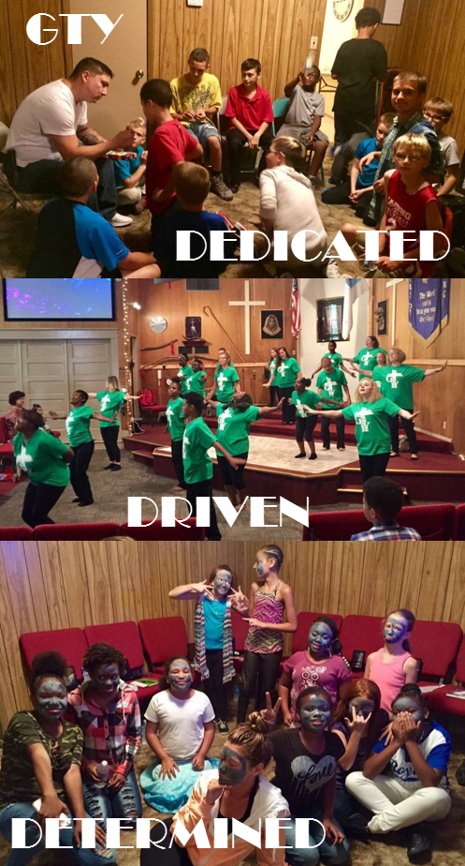  Be who you want to be, and not who you think you see!  “Do not let anyone look down on you because you are young. But set an example for the believers in speech, in life, in love, in faith and in purity.”  1 Timothy 4:12 | Our Purpose  It is our purpose as G.O.T.E.A.M. Youth to not only reach, but also teach all teenagers here at Faith Evangelistic Center and beyond, the Salvation and Love of Jesus Christ. We believe that God has given us all unique spiritual gifts that we are to use together as one team to reach teenagers of all races and backgrounds regardless of past or present lifestyle.  “We cannot always build the future for our youth, but we can build our youth for the future.”  Franklin D Roosevelt  For more information  Contact the church office:  Tuesday – Friday, 9:00am – 3:00pm  Phone: 913-682-4492  Email: faithevcenter@aol.com  Visit: 120 N. Broadway  Leavenworth, KS 66048  View us online:  https://www.faithevcenter.org/youth-ministry/ | 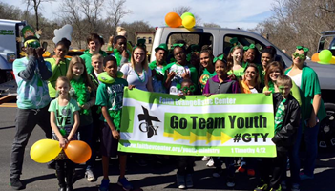  GTY Saint Patrick’s Day Parade LV,KS  Our Groups:  Juniors: 7th - 8th Grades  Seniors: 9th -12th Grades  Activities and Services  Sunday @ 9:00 am: 1st Service  Sunday @ 11:10 am: Sun School  Sunday @ 12:30 pm: 2nd Service  Tuesday @ 6:00 pm: Youth Activities & Fellowship  Wednesday @ 7:00 pm: Service  Note: Our Transportation Ministry will gladly pick youth up for services and activities; please contact the church office in advance for pick-up.

